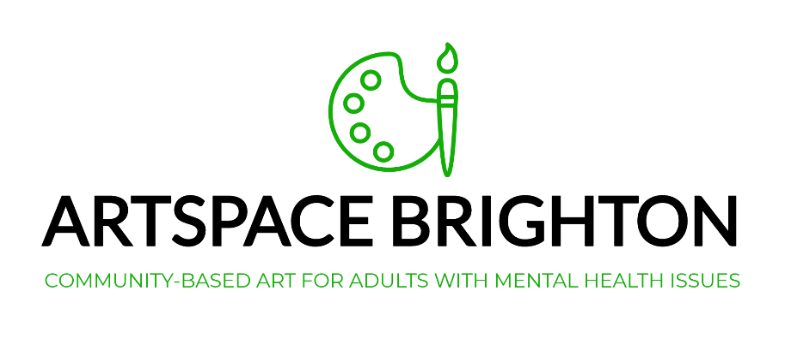

Dear Applicant,

Thank you for applying for the role of Voluntary Admin Officer at Artspace Brighton.

Artspace Brighton is a charity which provides a community-based art studio to adults experiencing mental health issues. Established in July 2013, the project has since been running successfully from a studio space on the Bristol Estate, East Brighton.

The charity is run solely by volunteers and we are now looking to enlist a bigger team to keep the project running smoothly as we continue to grow and develop.

This post requires that the post holder has the skills and experience outlined. In application, please address yourself to the points in the Role Description and Person Specification overleaf and explain clearly how your skills and experience meets these requirements.

Please don’t hesitate to contact us if you have any questions.

Kind Regards,
The Artspace Team
Artspace Brighton
Role Description and Person Specification for
Voluntary Admin Officer
Role title: Voluntary Admin Officer
Reports to: Trustee board
Salary: N/A – voluntary role
Hours: approx. five hours per week, to be worked flexibly – some evening work required when attending supervision or Trustee Meetings

Tasks and Responsibilities:
- To attend quarterly Trustee meetings in order to take minutes.
- To file and distribute minutes of meetings.
- To keep the digital filing system (Dropbox) updated and orderly.
- To support the Trustees and Lead Studio Facilitator with a range of admin tasks; correspondence, compiling lists of funders, updating spreadsheets, etc.
- To monitor the charity email inbox and respond and forward accordingly.
- To format and email / post out our quarterly Newsletter (which is written by studio facilitators).
- To assist with the construction of funding bids, with support from other volunteers.
- To assist the Operations Manager with putting together monitoring and evaluation reports.
- To occasionally book volunteers onto relevant training courses.
- To support the trustees in developing and maintaining all organisational policies and procedures.
- To assist in updating our social media and ordering and distributing our advertising materials.
- To liaise with other professionals, projects and organisations within the relevant fields in order to forge and maintain strong links.
- Any additional project-based tasks in line with the charity’s ongoing strategy.

Essential Experience:
- An ability to communicate clearly and effectively; both verbally and in writing.
- A working knowledge of Microsoft Office applications.
- An ability to be self-motivated across a broad spectrum of work.
- An ability and commitment to work effectively in partnership with the Trustee board and other Artspace Brighton volunteers.
- An ability to adapt in response to feedback and the lessons learned through practice.
- An ability to work to meet deadlines.
- An understanding of the importance of confidentiality.
- Experience of using social media.

Desirable Experience:
- Experience of working or volunteering in a previous administrative role.

*NB - No role description can cover every issue which may arise within the post at various times, and the post holder is expected to carry out other duties from time to time which are broadly consistent with those in this document.

